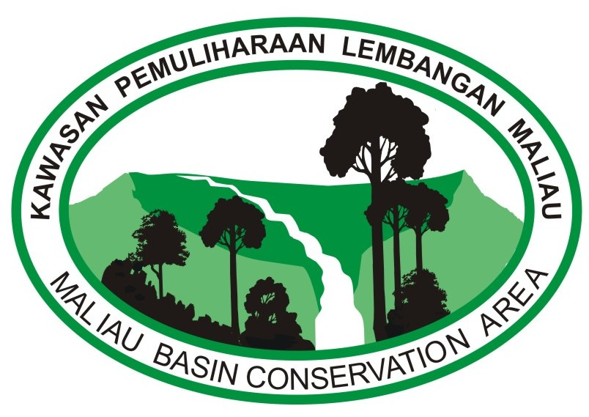
MALIAU BASIN CONSERVATION AREA
4 DAYS 3 NIGHTS TREKKING - “THE WONDERS OF MALIAU BASIN”

Studies Centre - Nepenthes Camp - Ginseng Camp
DAY | TIME | ACTIVITIES
Day 1 | 7:30 am  8:30 am | Breakfast  Depart to Agathis Research Station - the entrance to your journey into the lost world.  (packed lunch provided)  Start your journey into the wilderness on foot for about 7.5 km (4-6 hour) to reach Nepenthes Research Station. You will walk across the southern Basin rim through steep hills. Experience the forest changes from a mixed dipterocarp forest to lower montane forest with fewer tall trees. Spot at least six species of pitcher-plants, many species of Rhododendron and varieties of wild orchid along your way. (Difficulty rate: Challenging)  Take a rest around noon to have your lunch.
 | 3:00 pm | Expected to arrive at the Nepenthes Research Station or previously called the Camel Trophy Camp at 945 meters elevation. Have a good rest!
 | 1:30 pm | Begin your journey to explore another wonder with a 3 km trek to reach Giluk Waterfall, an easy-to-negotiate trail branch off northeast. (Advisable to bring headlight)
 | 2:30 pm | Expected to arrive at Giluk Waterfall.
 | 7:30 pm | Dinner at Nepenthes R.S.
 | 10:00 pm | Overnight at Nepenthes R.S. (Dormitory style)  Good Night and have a good rest!
Day 2 | 7:30 am | Breakfast
 | 8:30 am | Begin your journey to explore 3 wonderful Waterfalls (The Giluk Falls, The Fowzi Falls and The Takob-akob Falls)  Enjoy your packed lunch while resting at one of the waterfalls.
 | 4:00 pm | Trek back to Nepenthes Camp
 | 5:00 pm | Rest and enjoy the beautiful scenery
 | 7:30 pm | Dinner at Nepenthes R.C.
 | 10:00 pm | Overnight at Nepenthes R.S. (Dormitory style)  Good Night and have a good rest!
Day 3 | 6:30 am | Breakfast
 | 7:30 am | Bring along your bag packed and started your 10 km (7 hours) journey to the 7-tiered Majestic Maliau Waterfalls. (Difficulty rate: moderate to challenging)  (packed lunch provided)
 | 7:50 am | Stop by at the Nepenthes Garden. Spot the varieties of nepenthes species around the garden.
 | 2:30 pm | Expected to arrive at Maliau Waterfalls. The most spectacular waterfall, with its 7-tiers of cascading waters, said by the Murut to be home to a mythical water-dragon. These waterfalls, riverine stairways and avenues are unique and among the most beautiful features of the Basin. In fact, the Basin is thought to have more waterfalls in its 390sq. kms than any other place in Malaysia, possibly in the world! The Basin is drained by the tributaries of the Maliau River, which descends the magnificent Maliau Falls, before flowing through a gorge out of the south-east of the Basin into the Kuamut river which in turn feeds the mighty Kinabatangan, the longest river in Sabah.
 | 4:30 pm | Trek to Ginseng Research Camp to spend your night.
 | 6:30 pm | Expected to arrive at Ginseng Research Station (at 645 meters elevation) and rest.
 | 7:30 pm | Dinner
 | 10:00 pm | Overnight at Ginseng Research Station. (Dormitory style)  Good Night and have a good rest!
Day 4 | 6:30 am | Breakfast
 | 7:00 am  7:30 am | Embark on a 15 minutes’ walk to Ginseng Waterfall. One of the many wondrous waterfalls in Maliau Basin.  Trek back to Ginseng Research Centre
 | 8:00 am  8:15 am | Group Photos at Ginseng Research Centre  Packed all your belongings (including your litter), make sure you leave nothing but a footprint. Begin your journey back to Agathis Research Centre for another 9 km jungle trekking.  (Packed lunch provided)
 | 1:00 pm  2:00 pm | Expected to arrive at Agathis Research Centre and thereafter, depart to Maliau Shell Building for toilet stop.  Expected to arrive at Maliau Shell Building. Check-out and make use of the restroom to clean yourself. You may have your packed lunch at the Maliau Shell Building.
 | 3:00 pm | Safe journey to your next destination.

