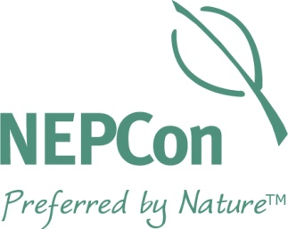

NEPCon Sustainable Tourism
Certification

GSTC Accredited

Initial Application

CONTACT INFORMATION

(For your application to be processed please complete all fields labeled as REQ)

Company Legal Name (REQ): |  |  |  |  |  |  | Trade Name or DBA* (REQ):
Date of application (REQ): |  |  |  |  |  |  | Jurisdiction of Company (Country):
Type of Legal Entity:
VAT or Tax Registration Number (REQ):
Primary Contact (REQ): |  |  |  |  |  |  | Title or position of primary contact (REQ):
Mailing Address (REQ):
City (REQ): |  |  |  |  | State/ Prov. (REQ): |  |  | Country (REQ):
Email(s) (REQ): |  |  |  |  |  |  |  | Post. Code:
Phone (REQ): |  |  | Fax: |  |  | Website (REQ):
* ”doing business as” – for contracting purposes please ensure that your company’s full legal name is listed above.

2. BUSINESS BACKGROUND

Help us create a profile of your business to plan for your tourism verification.

a) BUSINESS TYPE:

Please state the nature of your enterprise:
Private enterprise | Public enterprise | Community
Indigenous Community | Cooperative | Other

b) TYPE OF PRODUCT/SERVICE:
Lodging | Food Service | Tour Operator

c) BUSINESS DETAILS:
Number of rooms (Hotel Only) (REQ): | Number of employees (REQ): | Number of years in operation (REQ):
Destinations where it delivers its services (Tour Operators only) (REQ): | List all itineraries or tours that will be included under the scope of an eventual certificate (Tour Operators only) (REQ): | Cantidad de años en operación (REQ):
Number of customers served by operation in (REQ):
2016: 2017: 2018:

d) LOCATION:
How many hectares is the size of your property?
Is any portion of your property set aside for conservation and/or private reserve? Yes No
Are you located near a protected area? Yes No
If yes, name protected area:

3. ADDITIONAL COMMENTS/NOTES
Please provide any additional information or comments which will help us better understand your operation:

_____________________________________ _____________________
Signature of authorized representative Date

