Product Job Card cum Production Order

TMP.14 Ver 2.0

PRODUCT JOB CARD /  PRODUCTION ORDER |  |  |  |  |  |  | Production  Number |  | A010 |  | Draw. Code |  | 222 | Product Name |  |  | Coffee table |  |  |  |  |  | Quantity |  | 450
 |  |  |  |  |  |  | Customer  P.O No. |  | 199 VN _2015 |  |  |  | Date | 13-Sep-13 |  | Species |  |  | Processed product volume (m3) |  | Processed job volume (m3) |  |  | Minimum volume of raw wood (m3)
ENV  Claims | FSC | X | PEFC |  | Non-cert |  | Customer |  | Jone and John |  |  |  | Cont. | 01x40' |  | Acacia |  |  | 0.038321 |  | 38.5000 |  |  | 36.54
Item No. | Item Name |  |  |  |  |  | Pcs in one product | Raw Dimension (mm) |  |  |  | W-% | Processed Dimension (mm) |  |  | Processed Volume / Item |  | Percent. / product | Expected Waste |  | Total
 |  |  |  |  |  |  |  | Thick. | Width | Length |  |  | Thick. | Width | Length |  |  |  | Process | Reject | Quantity | m3 |  | Sum  Thickness |  | Volume m3
1 | Long frame bar |  |  |  |  |  | 2 | 38 | 58 | 1520 |  | 16% | 34 | 55 | 1500 | 0.005610 |  | 10% | 20% | 3 % | 927 | 3.73 |  | 38 |  | 28.10
2 | Short frame bar |  |  |  |  |  | 2 | 38 | 58 | 840 |  | 17% | 34 | 55 | 820 | 0.003067 |  | 6% | 20% | 3 % | 927 | 2.06 |  | 28 |  | 0.72
3 | Table top slat |  |  |  |  |  | 10 | 38 | 58 | 1820 |  | 16% | 34 | 55 | 1800 | 0.033660 |  | 61% | 20% | 3% | 4.635 | 22.31 |  | 69 |  | 7.72
4 | Supporting bar |  |  |  |  |  | 2 | 28 | 27 | 860 |  | 26% | 24 | 24 | 840 | 0.000968 |  | 2% | 20% | 3% | 927 | 0.72
5 | Table leg |  |  |  |  |  | 4 | 69 | 68 | 740 |  | 12% | 65 | 65 | 720 | 0.012168 |  | 22% | 20% | 3% | 1.854 | 7.72
6
7 |  |  |  |  |  |  | 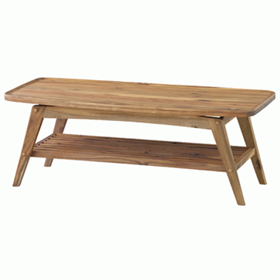
8
9
10
11

