**Example of completed supply chain diagram**

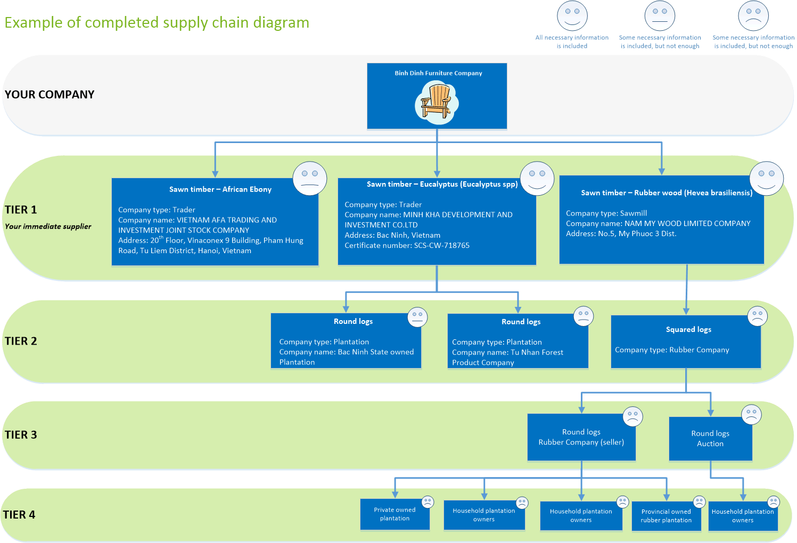

**QG.04 Ver 2.0**



Increasing capacity of CSOs and SMEs to implement FLEGT requirements. This project is partly funded by the European Union

This publication has been produced with the assistance of the European Union. The contents of this publication are the sole responsibility of NEPCon and can in no way be taken to reflect the views of the European Union.